|  |  |
| --- | --- |
| Welcome | **Al Maaref University**  **Faculty of Business Adminstration**  **Department of Business**  Summer 2023 - 2024 |

**Practical Training (COE 497) Report**

**Student ID :** 10121103

**Student Name :** Fatima AL-Dika

**Data Engineering Bootcamp**

DGPAD-MENTIS company

Beirut, Lebanon

Company Coordinator: Kassem Shehade

University Advisor : Dr. Kassem Danach

Table of Contents

Company Information 4

Company Products and Services 4

Internship Information 5

Internship Abstract 5

Internship Plan and Responsibilities 5

Achievement Details 6

Achieved Development Areas 6

Hardware Environment 6

Software Platform 6

Learned Technologies 6

Used Tools 6

Product Benefits 7

Product Repository Link 7

Product Images Overview 7

Critical Analysis 10

Challenges Faced 10

Compatibility of University Courses 10

Personal Benefits 10

Professional Benefits 10

Comments on the Company 10

Work Opportunity 10

# Company Information

**Company Name :** DGPAD-MENTIS

**Company Domain :** Data Science and Web Development

**Company Size :** approximately10 employees

**Company Sales Size (if available) :** _

**Company Website :** https://dgpad.io

## Company Products and Services

* Providing internships to university students with experts in the domain of these internships to enter the market with more enhanced skills relevant to the job field students want to enter.
* Giving the participants access to many materials or other internships or sites that’re important in their study-work life journey.

# Internship Information

**Training Title :** Data-Engineering-Branch Bootcamp

**Company Department :** …

**Internship Duration (hours) :** 18

**Company Coordinator :** Kassem Shehade

**Company Coordinator (email) :** kassemshhaddy@gmail.com

**University Advisor :** Kassem Danach

**University Advisor (email) :** kassem.danach@mu.edu.lb

## Internship Abstract

During this internship period I want to sharpen my skills and information in data-engineering, and further mode to try company-grade tasks and how I can finish them in a giving time interval, also during this internship I wanted to build more connection and a profile to better find a chance in the job field

## Internship Plan and Responsibilities

1. Web scraping of Al-Mayadeen articles using Python.
2. Data storage in MongoDB and Flask API development using Python.
   1. Storing the previously-obtained-articles-data in MongoDB.
   2. Building a relevant Flask API for data query purposes.

# Achievement Details

## Achieved Development Areas

Database: Mongo DB

Frontend: HTML/CSS

Mobile/Desktop (Responsive Design): none

## Hardware Environment

Computer specs:

* Device name: DESKTOP-JO4LG69.
* Processor: Intel(R) Core(TM) i7-8650U CPU @ 1.90GHz 2.11 GHz
* System type: 64-bit operating system, x64-based processor.
* Memory: 8GB ram

## Software Platform

I’ve worked on Windows platform on my own laptop during the whole internship period.

## Learned Technologies

Flask

## Used Tools

Many software tools have been used during this training period to achieve the internship goals and achieve the needed tasks, and this includes:

1. PyCharm Community Edition 2020.3.2 x64. (The famous ide from jetBrains)
2. MongoDB Compass. (A no-sql database manager)
3. Postman. (To make sure of the website functions)
4. Opera Gx
5. Github (a version control cloud system)

## Product Benefits

It can be used to develop a relevant visualization app ready to be deployed -along with the prepared database collections- to a certain cloud server so that it can be accessed by any user having the right to access so, so the user can see smoothing insights of data collected from thousands of Al-Mayadeen recent articles.

## Product Repository Link

Below is the link of my own project GitHub repository:

*https://github.com/gitfatz/dgPad_Flask*

[*https://github.com/gitfatz/Dgpad*](https://github.com/gitfatz/Dgpad)

*Note:* It’s a private repository.

## Product Images Overview

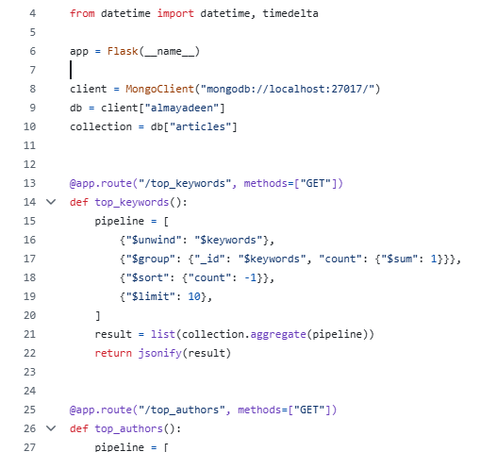

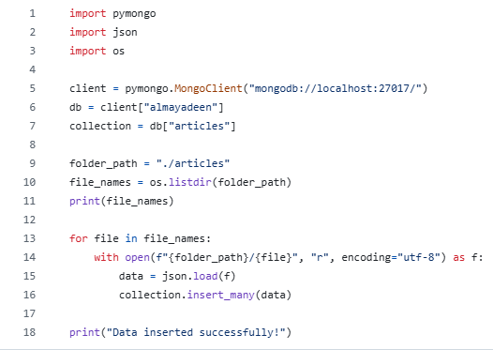

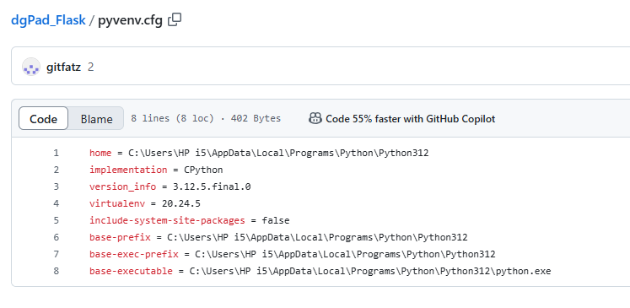

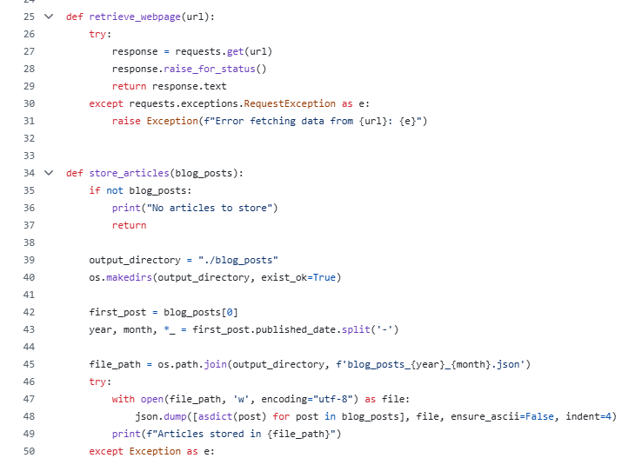

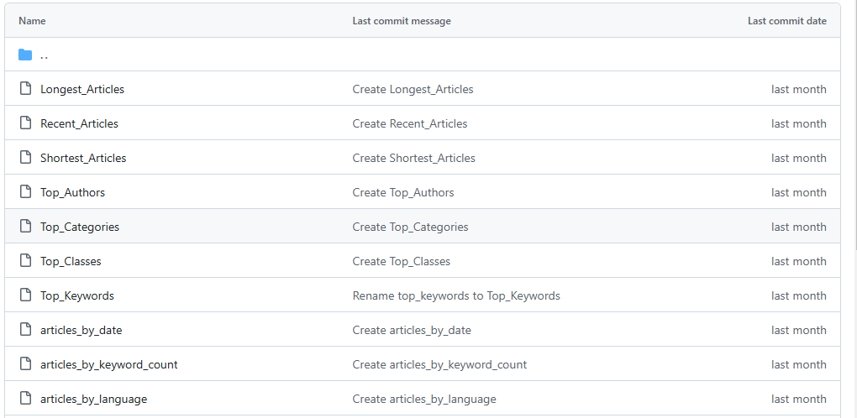

# Critical Analysis

## Challenges Faced

1. Lebanon-current-situation challenges:
2. Limited laptop power
3. Internet severe shortage due to the ongoing crisis

## Compatibility of University Courses

* Basic programming courses
* Web Development.

## Personal Benefits

* Confidence: I have more confidence in presenting my work even though it is not perfect
* Will and persistence: even though I was displaced due to the ongoing aggression, I tried to
* Comfort:

## Professional Benefits

* Exploring and using new technologies and applications used in data science/engineering field.
* Enhancing existing skills in programming languages used during this internship.
* Making the road to data-engineer job more obvious.

## Comments on the Company

The Company was very understanding and compassionate with the students especially in times of war, as they were forgiving and flexible with timings and deliveries

## Work Opportunity

This company -until the moment of writing my report- just performs internships for university students in the fields listed before (according to the company’s official website), and so the company aim is to enhance students’ skills to be eligible to work on other companies, especially the top ones in these fields in Lebanon or outside it.